1. What is the most expensive product?

SELECT TOP 1 ProductName, Price
FROM Products
ORDER BY Price DESC;

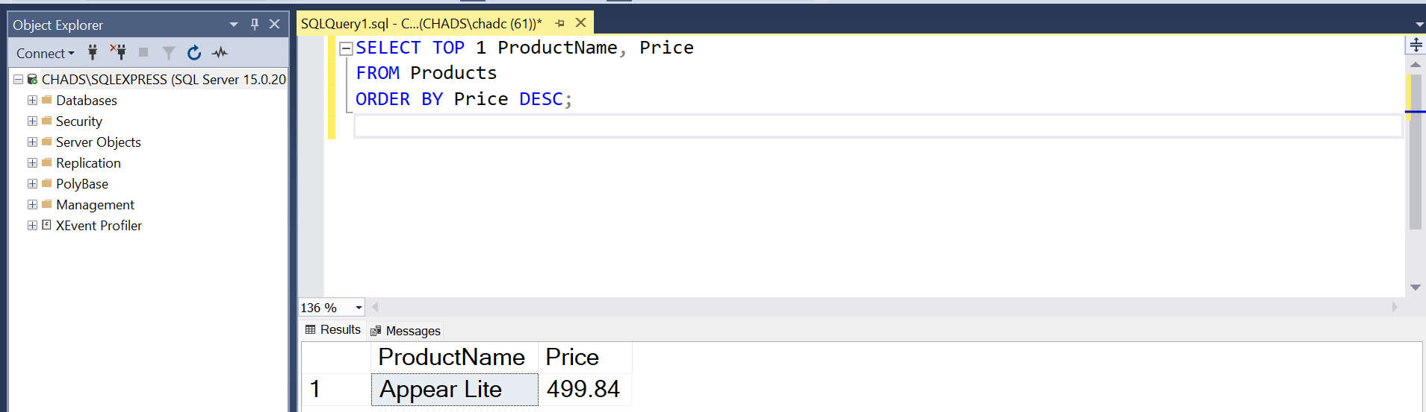

Or

SELECT TOP 1 productname, max(price) as MostExpensiveItem
FROM Products
GROUP by productname
ORDER by MAX(price) DESC

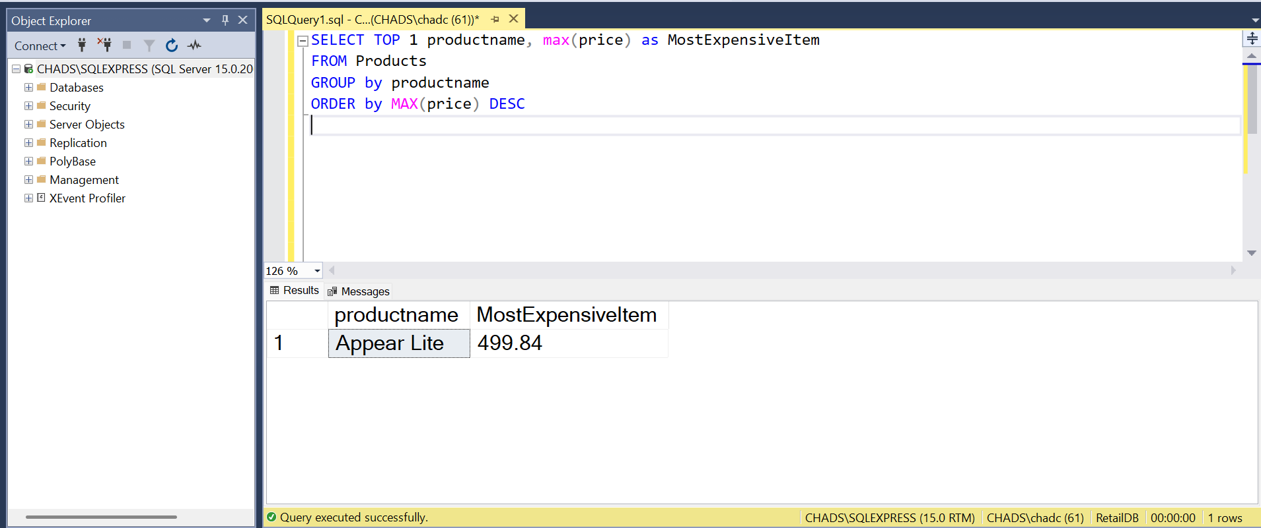

2. Which top 5 customers have placed the highest value orders?

SELECT top 5 c.CustomerName, o.OrderID, o.TotalAmount
FROM Orders o
JOIN Customers c ON o.CustomerID = c.CustomerID
ORDER BY o.TotalAmount DESC

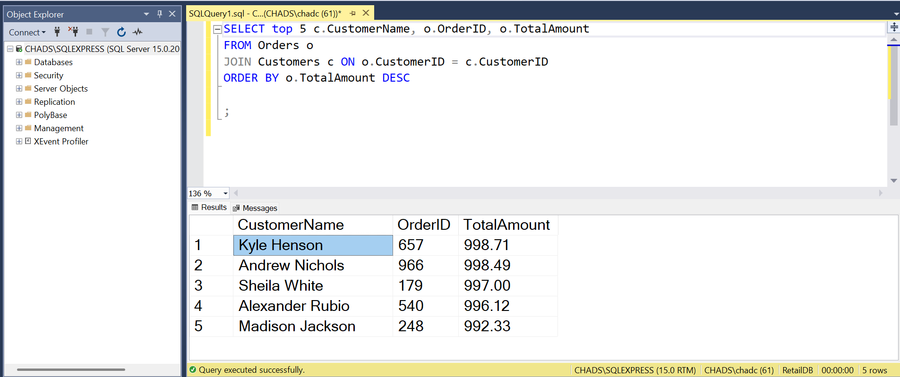

3. Find the 5 most frequently ordered products (not using the “TOP” command).

SELECT p.ProductName, COUNT(oi.OrderItemID) AS TimesOrdered
FROM OrderItems oi
JOIN Products p ON oi.ProductID = p.ProductID
GROUP BY p.ProductName
ORDER BY TimesOrdered DESC
OFFSET 0 ROWS FETCH NEXT 5 ROWS ONLY;
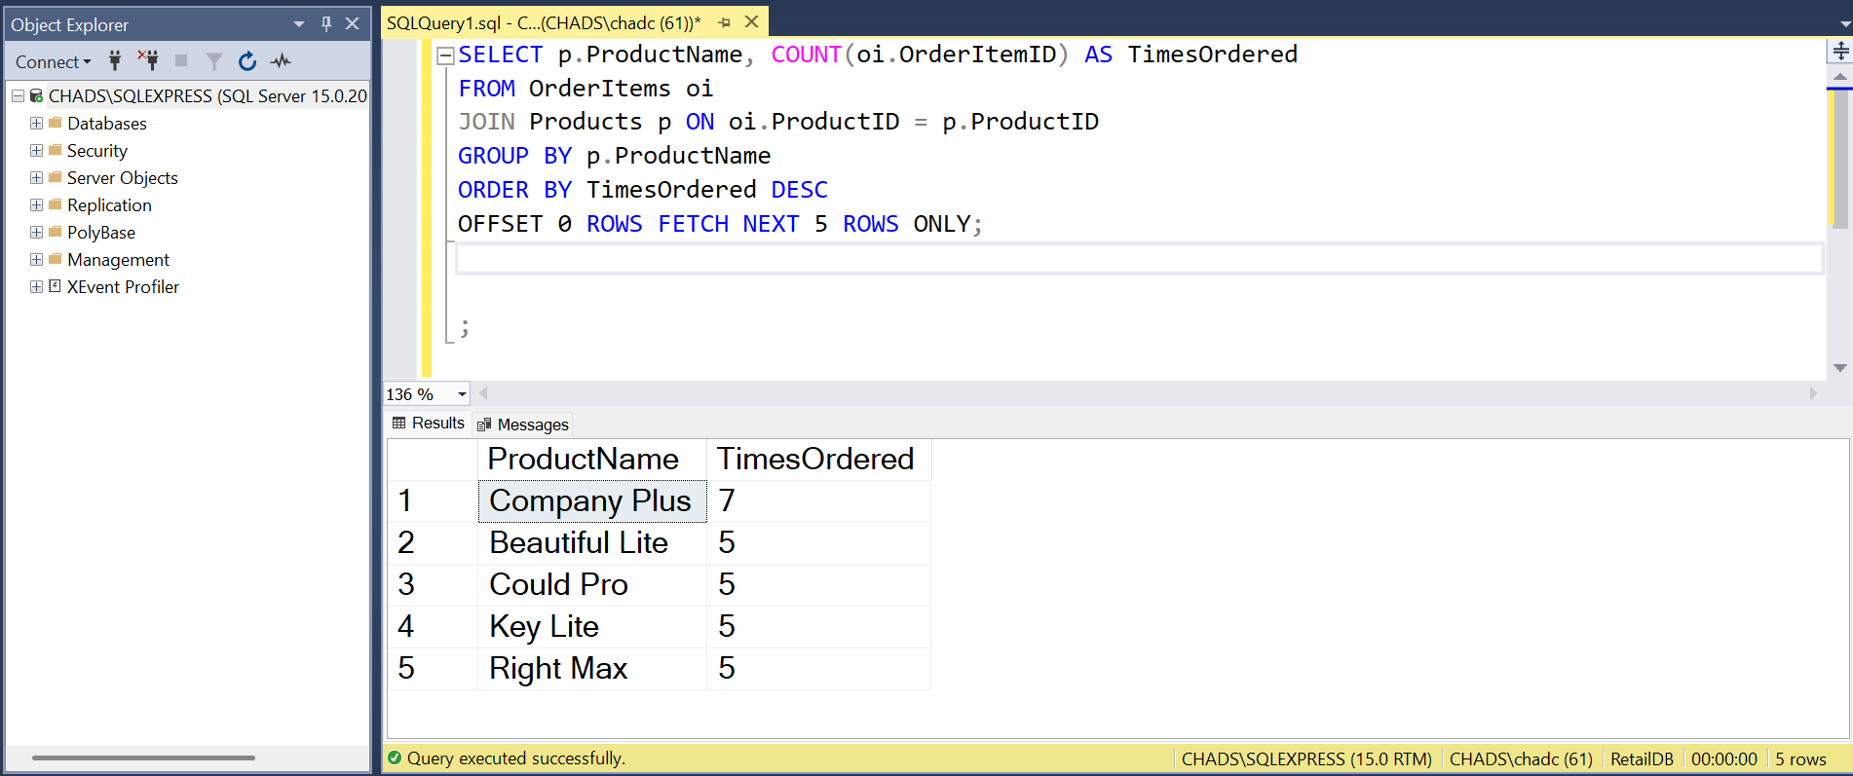

4. List customers who have never placed an order.

SELECT CustomerName
FROM Customers
WHERE CustomerID NOT IN (SELECT DISTINCT CustomerID FROM Orders);

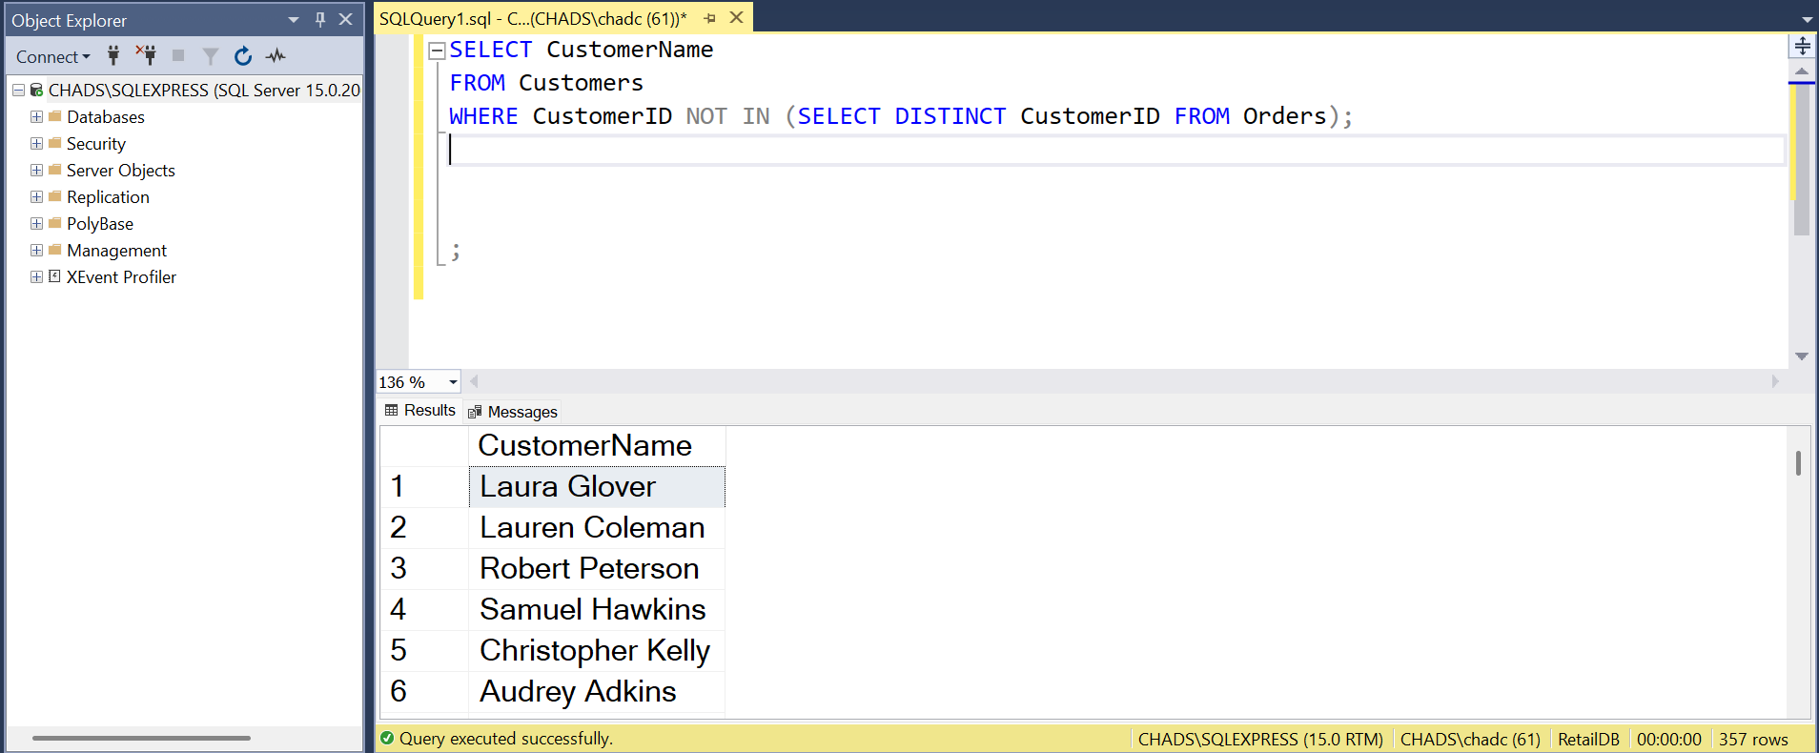

5. Find total revenue per customer.

SELECT c.CustomerName, SUM(o.TotalAmount) AS CustomerRevenue
FROM Customers c
JOIN Orders o ON c.CustomerID = o.CustomerID
GROUP BY c.CustomerName
ORDER BY CustomerRevenue DESC;

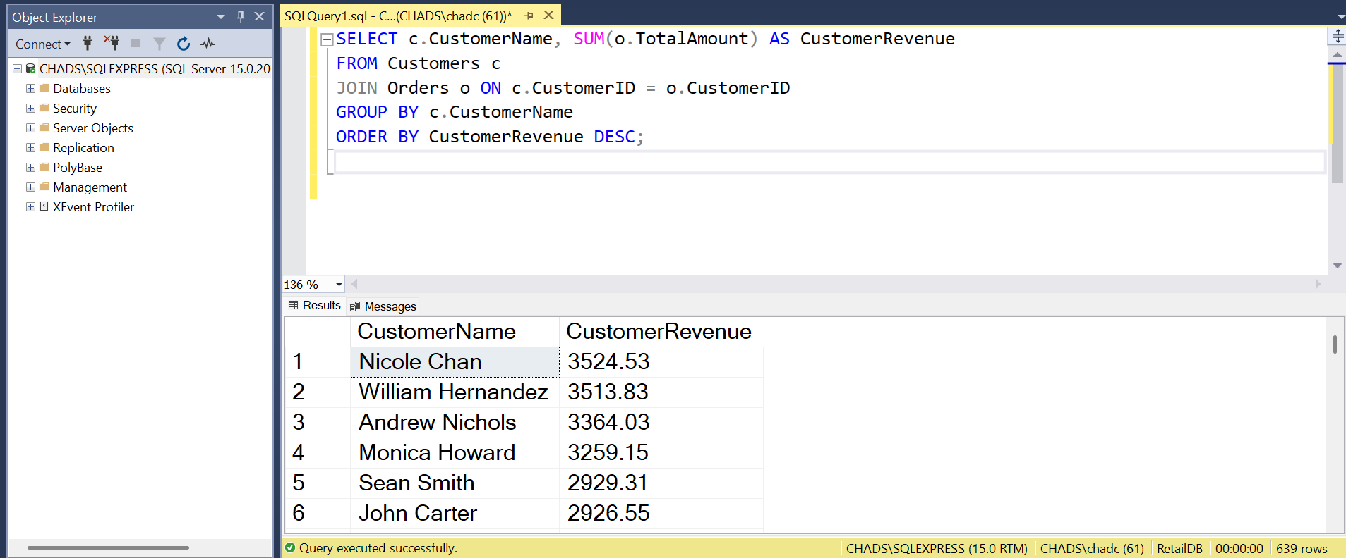

6. List products ordered more than 20 times.

SELECT p.ProductName, SUM(oi.Quantity) AS TotalOrdered
FROM OrderItems oi
JOIN Products p ON oi.ProductID = p.ProductID
GROUP BY p.ProductName
HAVING SUM(oi.Quantity) > 20
ORDER BY TotalOrdered DESC;

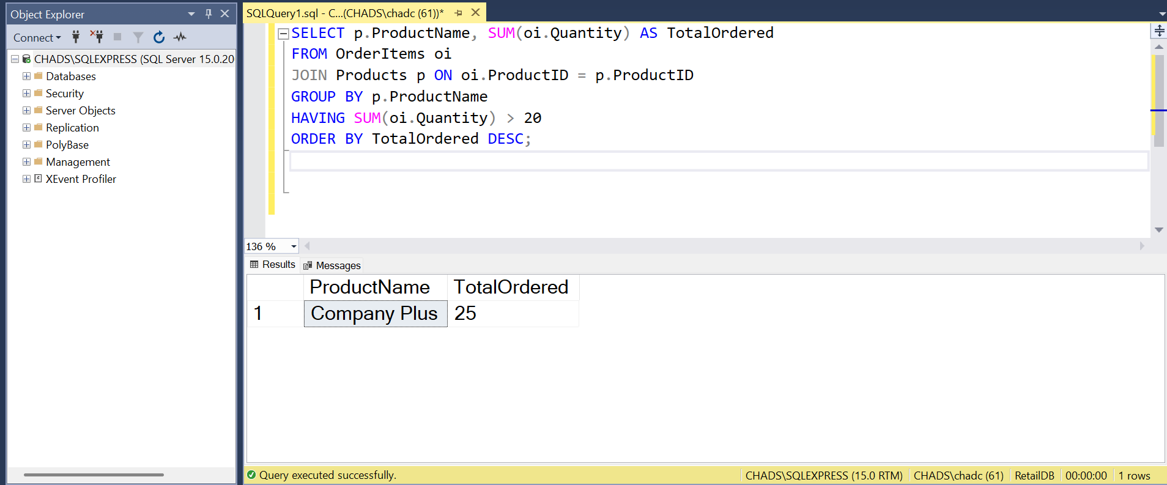

7. What is the average revenue per customer?

SELECT AVG(CustomerRevenue) AS AverageRevenuePerCustomer
FROM (
SELECT SUM(o.TotalAmount) AS CustomerRevenue
FROM Orders o
GROUP BY o.CustomerID
) AS CustomerRevenues;

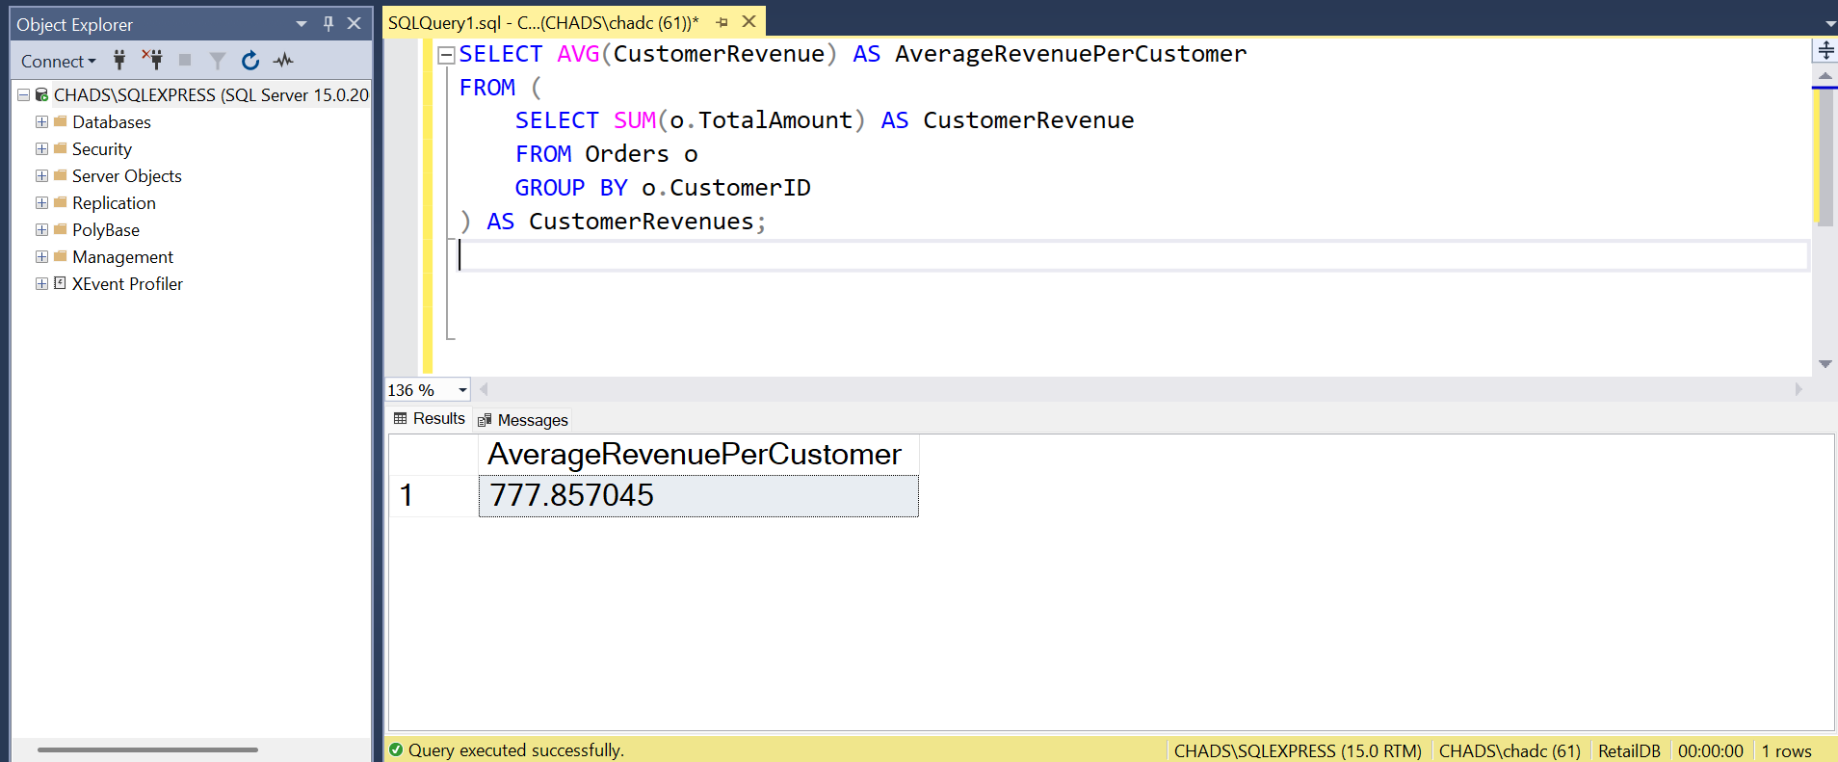

8. Find the number of customers per state.

SELECT State, COUNT(*) AS NumberOfCustomers
FROM Customers
GROUP BY State
ORDER BY NumberOfCustomers DESC;

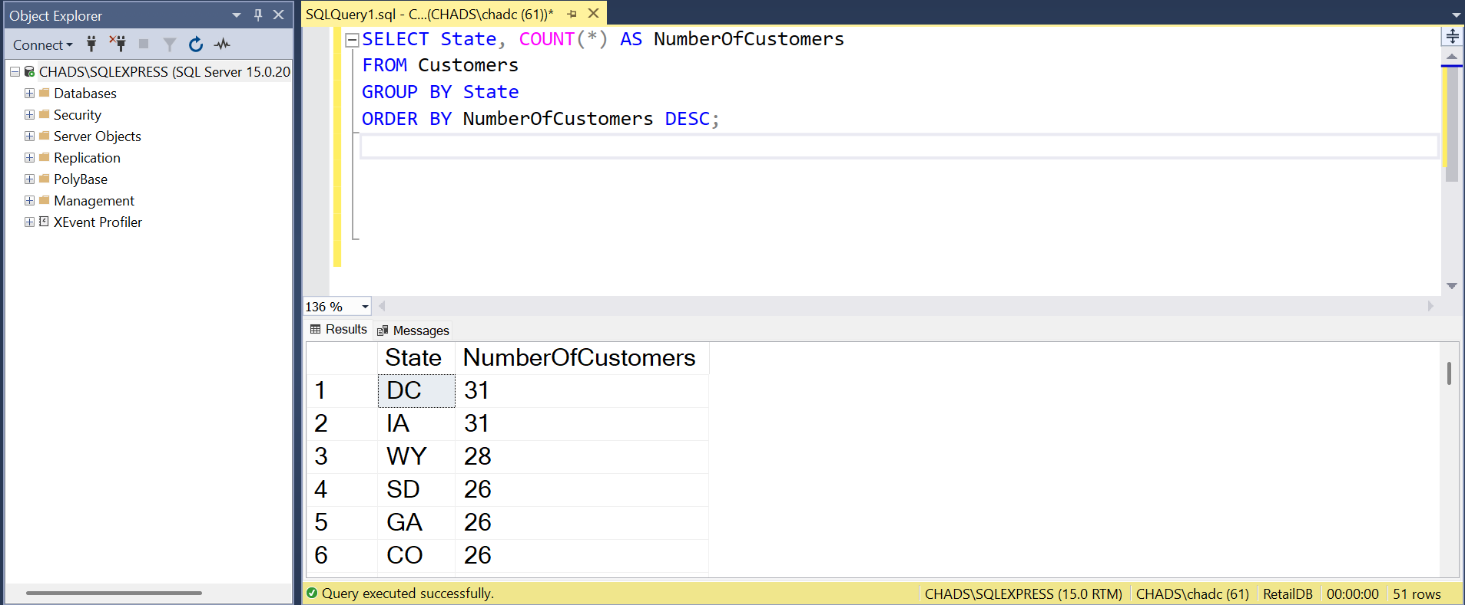

9. List the products with the highest stock quantity.

SELECT ProductName, StockQuantity
FROM Products
ORDER BY StockQuantity DESC;

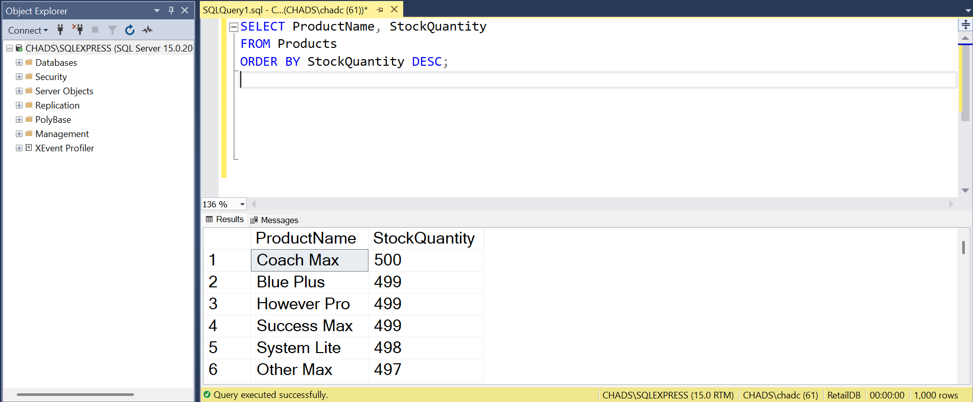

10. Find the revenue generated per product.

SELECT p.ProductName, SUM(oi.Quantity * oi.ItemPrice) AS ProductRevenue
FROM OrderItems oi
JOIN Products p ON oi.ProductID = p.ProductID
GROUP BY p.ProductName
ORDER BY ProductRevenue DESC;

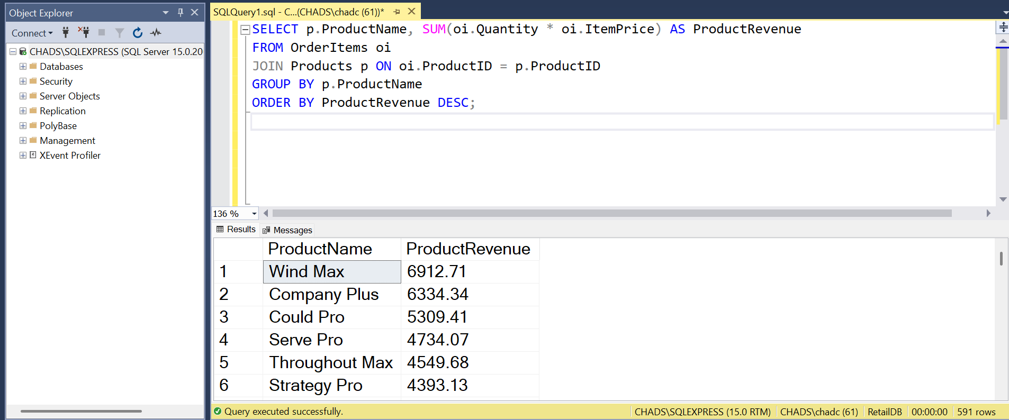

11. Calculate total units sold across all products.

SELECT SUM(Quantity) AS TotalUnitsSold
FROM OrderItems;

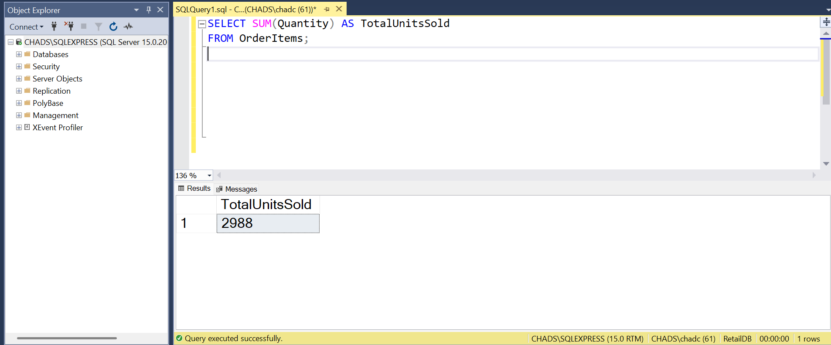

12. List the top 5 cities by number of orders placed.

SELECT Top 5 c.City, COUNT(o.OrderID) AS OrdersCount
FROM Orders o
JOIN Customers c ON o.CustomerID = c.CustomerID
GROUP BY c.City
ORDER BY OrdersCount DESC

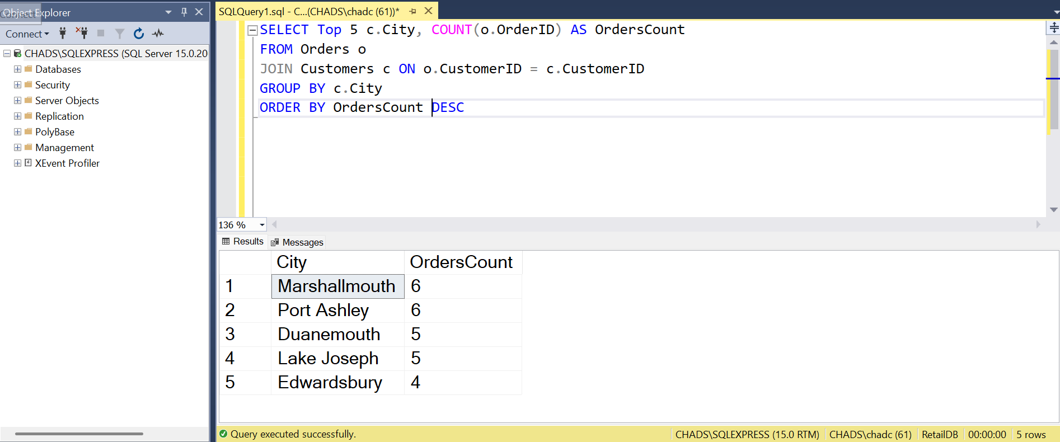

13. Which orders have the highest number of items?

SELECT o.OrderID, SUM(oi.Quantity) AS TotalItems
FROM OrderItems oi
JOIN Orders o ON oi.OrderID = o.OrderID
GROUP BY o.OrderID
ORDER BY TotalItems DESC;

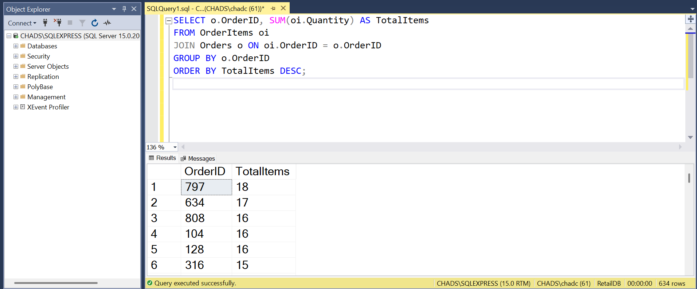

14. Show the monthly trend of new customer signups.

SELECT FORMAT(SignupDate, 'yyyy-MM') AS SignupMonth, COUNT(*) AS NewCustomers
FROM Customers
GROUP BY FORMAT(SignupDate, 'yyyy-MM')
ORDER BY SignupMonth;

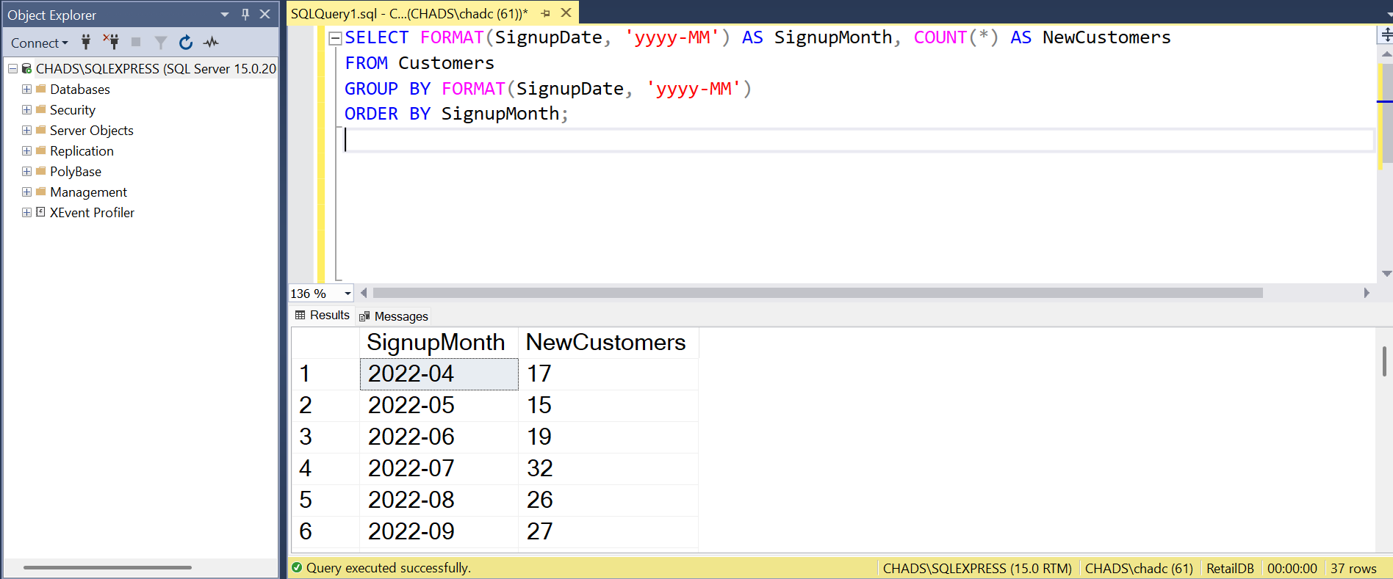

15. Find customers who placed more than 5 orders.

SELECT c.CustomerName, COUNT(o.OrderID) AS OrdersPlaced
FROM Customers c
JOIN Orders o ON c.CustomerID = o.CustomerID
GROUP BY c.CustomerName
HAVING COUNT(o.OrderID) > 5
ORDER BY OrdersPlaced DESC;

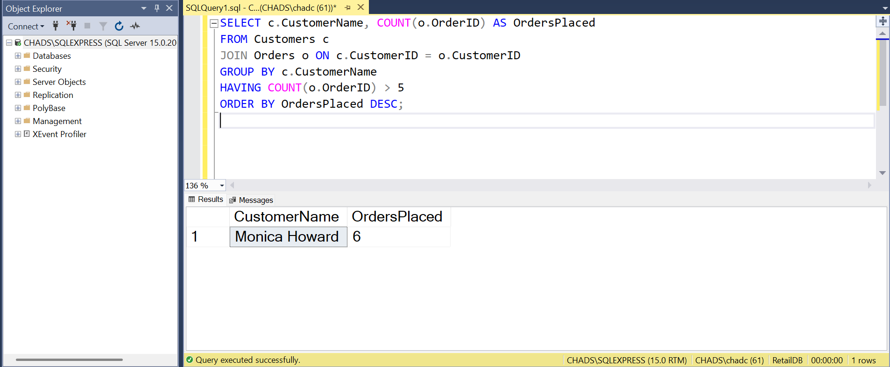

16. Which product categories generate the most revenue?

SELECT p.Category, SUM(oi.Quantity * oi.ItemPrice) AS CategoryRevenue
FROM OrderItems oi
JOIN Products p ON oi.ProductID = p.ProductID
GROUP BY p.Category
ORDER BY CategoryRevenue DESC;

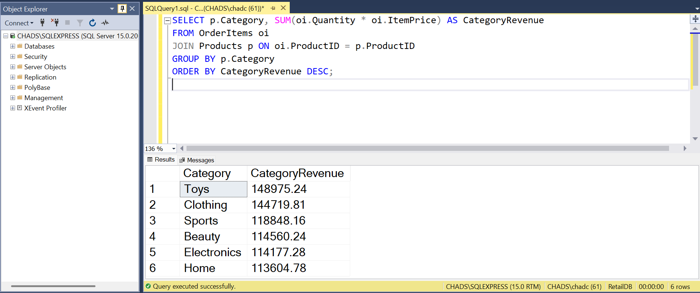

17. Find customers who spent more than $1000.

SELECT c.CustomerName, SUM(o.TotalAmount) AS TotalSpent
FROM Customers c
JOIN Orders o ON c.CustomerID = o.CustomerID
GROUP BY c.CustomerName
HAVING SUM(o.TotalAmount) > 1000
ORDER BY TotalSpent DESC;



18. What is the lowest priced product?

SELECT TOP 1 ProductName, Price
FROM Products
ORDER BY Price ASC;

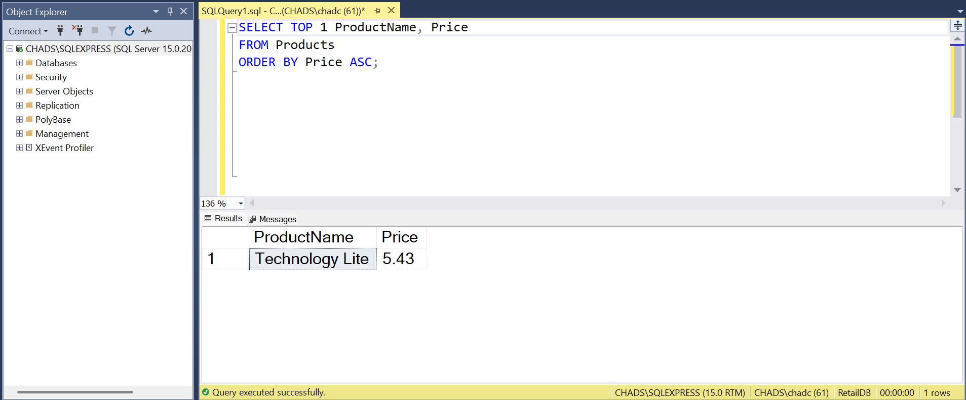

19. List orders placed in the last 7 days.

SELECT OrderID, CustomerID, OrderDate, TotalAmount
FROM Orders
WHERE OrderDate >= DATEADD(DAY, -7, GETDATE())
ORDER BY OrderDate DESC;

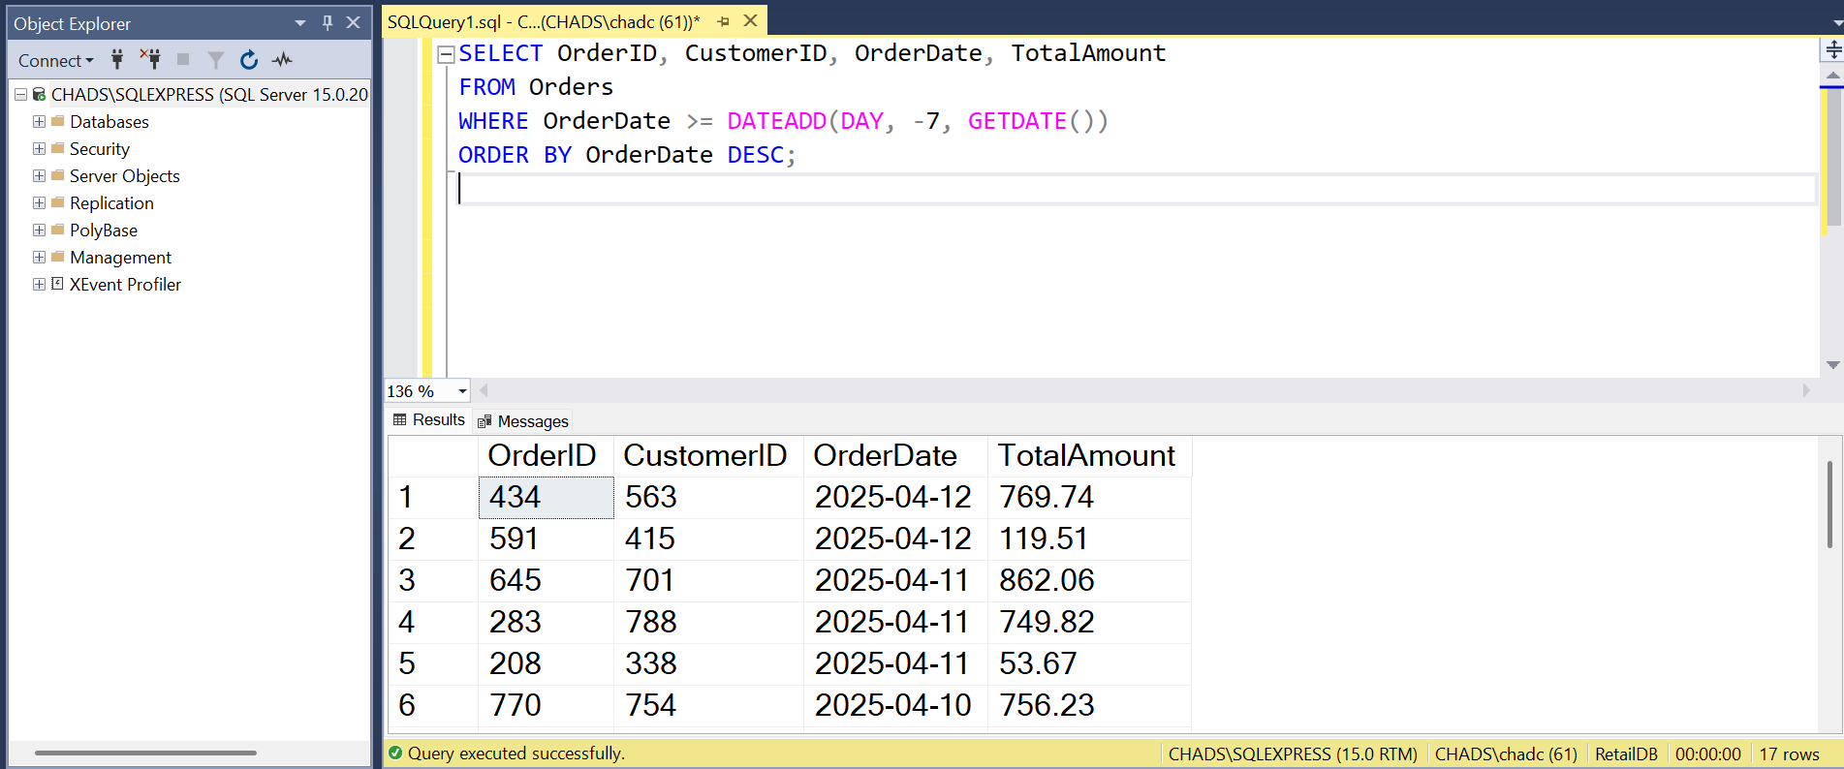

20. Find the percentage of products that have been sold at least once.

SELECT
CAST(COUNT(DISTINCT oi.ProductID) AS FLOAT) / COUNT(DISTINCT p.ProductID) * 100 AS SoldPercentage
FROM Products p
LEFT JOIN OrderItems oi ON p.ProductID = oi.ProductID;

